

SCHOOL OF COMPUTER SCIENCE

AND ENGINEERING

|  |  |
| --- | --- |
| **Module Title:** | **Mathematics for Computing** |
| **Module Code:** | **4COSC002W.1** |
| **Exam Period:** | **15 December 2023** |
| **Time allowed:** | **90 minutes** |
|  |  |

**INSTRUCTIONS FOR CANDIDATES**

* Students who arrive more than 30 minutes late will not be permitted to enter the examination room and must apply for Mitigating Circumstances.
* Exiting the examination room is not allowed during the first 30 minutes and the last 15 minutes of the exam period.
* You are advised (but not required) to spend the first ten minutes of the examination reading the questions and planning how you will answer them.
* Students are not allowed to visit the toilet unaccompanied. If you need a comfort break during the examination, please be escorted by a tutor. We ask everyone to minimise disturbances when moving in and out of rows.
* Calculators may be used provided they are silent, cordless, not pre-programmed by the candidate and cannot receive or transmit data remotely.
* It is mandatory to answer ALL QUESTIONS. The marks allocated for each task are indicated within the task's description.

___________________________________________________________

**The following information is given:**

Stats Basics Formulae – Appendix 1

**IN-CLASS TEST 2**

**THIS PAPER MUST NOT BE TAKEN OUT OF THE EXAMINATION ROOM**

**DO NOT TURN OVER THIS PAGE UNTIL THE INVIGILATOR**

**INSTRUCTS YOU TO DO SO**

**© UNIVERSITY OF WESTMINSTER, 2023-2024**

**PART A – SHORT ANSWERS**

*(Provide concise, direct answers to each question. No additional explanations or workouts should be provided)*

**QUESTION 1**

Fill the gaps in the given statements:

1. A matrix that has 1’s on the diagonal and 0’s elsewhere is called an ________ matrix.
2. A matrix where all elements off the main diagonal are zero, but the diagonal itself can contain non-zero elements, is known as a ________ matrix.
3. The probability of rolling a specific number on a six-sided die is an example of ________ probability.
4. A graph is connected if for every pair of nodes, there is a ________ between them.
5. The depth of a node in a tree is the number of ________ from the root to that node.

**SOLUTION**

1. Identity
2. Diagonal
3. Theoretical
4. Path
5. Edges

**QUESTION 2**

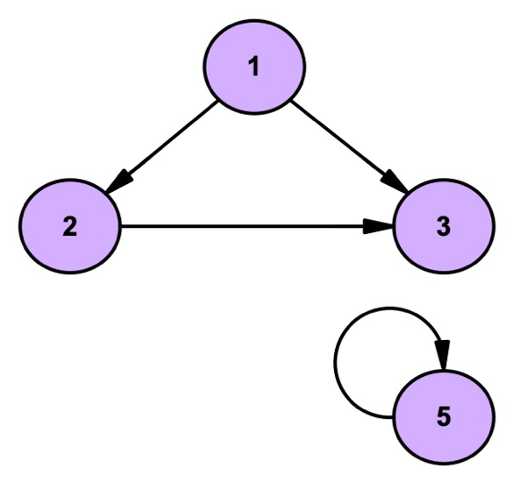

For the following **graph N** represented above, do the following:

1. form graph notation for the given graph N: a set **V** of all its nodes and set **E** of all its edges;
2. determine if it is a *directed* or *undirected* graph;
3. determine if it is a *connected* or *disconnected* graph;
4. determine if it is a *cyclic* or *acyclic* graph;

**SOLUTION**

1. V={1,2,3,5}, E={(1,2), (1, 3), (2,3), (5,5)}
2. Directed
3. Disconnected
4. Cyclic

**QUESTION 3**

You are given the following equation, where is an unknown matrix:

Find the values of and in the matrix that satisfy this equation.

**SOLUTION:**

*Step 1:* Set up the Equation with Unknown Matrix X

Let .

The equation becomes:

*Step 2:* Expand and Rearrange the Equation

Expanding both sides of the equation:

This simplifies to:

*Step 3:* Equate Corresponding Elements

Equate the corresponding elements on both sides:

*Step 4:* Solve the Equations

Solve each equation for and :

Final Solution:

The full matrix satisfying the equation is:

**Answer:** ,

**QUESTION 4**

Given matrices and :

Calculate the matrix such that . Identify the elements and in your answer, where the first index indicates the row and the second index indicates the column.

**SOLUTION**

Perform matrix multiplication of and to obtain .

The resulting matrix will be:

From , determine:

(first row, first column).

(second row, first column).

Now, let's calculate and find the specified elements.

The calculated matrix for the specified matrix multiplication task is:

**Answer:**  = , = .

**QUESTION 5**

A software company has developed 100 programs, with the following distribution:

- 25 programs written in Python.

- 30 programs written in Java.

- 20 programs written in C++.

- The remaining programs are written in JavaScript.

Find the probability of selecting a program that is not written in Java.

**SOLUTION**

Step 1: Determine the Total Number of Programs

Total number of programs developed by the company is given as 100.

Step 2: Calculate the Number of Programs Not Written in Java

To find the number of programs not written in Java, we subtract the number of Java programs from the total number of programs.

- Total programs: 100

- Java programs: 30

- Programs not written in Java = Total programs - Java programs = 100 - 30 = 70

Step 3: Calculate the Probability

The probability of selecting a program not written in Java is the ratio of the number of non-Java programs to the total number of programs.

- Probability

The probability of randomly selecting a program that is not written in Java is 0.7 or 70%.

**Answer:** 0.7

**QUESTION 6**

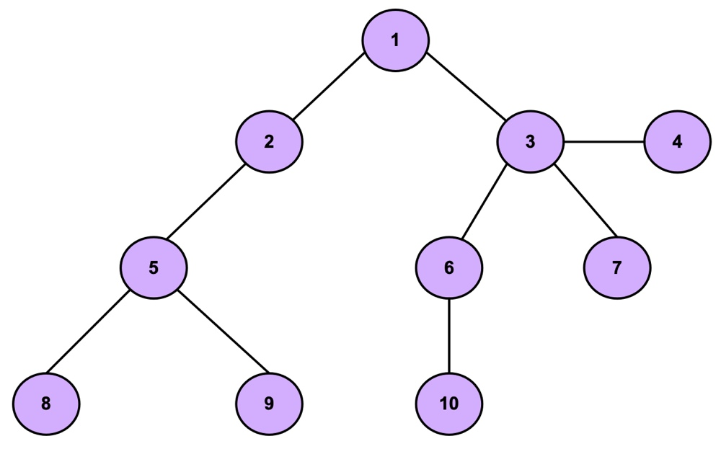

Tree H is given above.

Identify:

1. all the leaves of a tree;
2. depth of a tree;
3. is the given tree a binary tree (yes/no)?

**SOLUTION**

1. 4, 7, 8, 9, 10
2. 3
3. No

**PART B – DETAILED WORKOUTS**

*(Provide a comprehensive, step-by-step workout of each question. Each step should include relevant formulas, calculations, and brief explanations where necessary to justify your approach).*

**QUESTION 1**

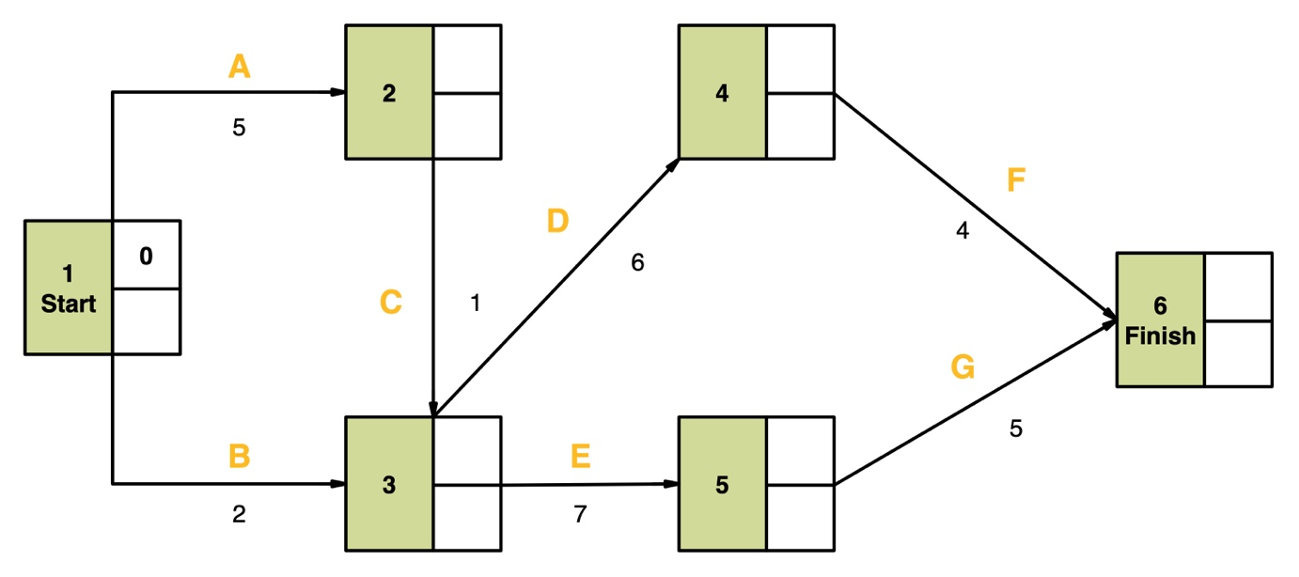

The provided diagram represents a project schedule using a network graph, where each node (or box) represents a task within the project. The edges represent activity and are labelled with letters, and the duration of each task is given below. The arrows indicate the sequence of tasks, demonstrating which tasks must be completed before others can begin.

Using the provided network graph, your objective is to perform a critical path analysis. This will involve identifying the longest path through the network and determining when the project can be completed.

For your analysis, follow these steps:

1. Draw the provided network graph on your answer booklet. Fill in all the empty cells (EST and LFT) for each node.
2. Provide the calculations of the Earliest Start Time (EST, the upper empty cell of the node) and the Latest Finish Time (LFT, the lower empty cell of the node) for each task.
3. Identify the critical path, which is the path from Start to Finish that has zero slack for all tasks. Show the critical path on your drawn graph. If there is more than one critical path, name at least one.

**SOLUTION**

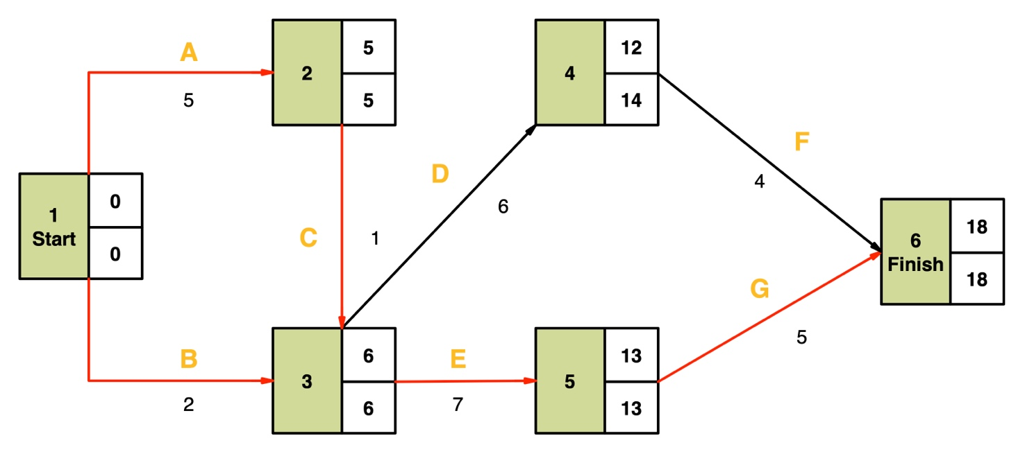

|  |  |  |
| --- | --- | --- |
| Node | EST | LFT |
| 1 | 0 | MIN (6-2, 5-5) |
| 2 | 0+5=5 | 6-1=5 |
| 3 | MAX (0+2, 5+1) | MIN (13-7, 14-6) |
| 4 | 6+6=12 | 18-4=14 |
| 5 | 6+7=13 | 18-5=15 |
| 6 | MAX (14+4, 13+5) | 6-1=5 |

1. There are two critical paths in this network graph: 1-2-3-5-6 and 1-3-7-5.

**QUESTION 2**

A fair die is rolled twice, yielding two outcomes: (the result of the first roll) and (the result of the second roll). Consider two events:

**Event A:** or (at least one of the rolls results in a 5).

**Event B:** (the sum of the two rolls is 8).

Find the conditional probability , which is the probability of Event A occurring given that Event B has occurred.

**SOLUTION**

To find , we need to identify the outcomes that satisfy both Event A and Event B. We'll use the formula for conditional probability:

We need to calculate:

1. The sets of outcomes satisfying Events A and B, and their intersection .
2. The probabilities and .
3. The conditional probability .

*Step 1:* Identify Outcomes for Events A and B

Outcomes for Event A: All pairs where at least one roll is 5.

Outcomes for Event B: All pairs where the sum of the rolls is 8.

*Step 2:* Find Intersection of A and B

Outcomes for : Pairs that satisfy both Event A and Event B.

*Step 3:* Calculate Probabilities

Probability of (P(A ∩ B)): The number of outcomes in divided by the total number of outcomes (36).

Probability of B (P(B)): The number of outcomes in B divided by the total number of outcomes (36).

*Step 4:* Calculate Conditional Probability

*Final Solution:*

The conditional probability , the probability of rolling at least one 5 given that the sum of the rolls is 8, is approximately or .

**QUESTION 3**

Analyse network latency by examining the time taken for packets to travel to a server and back. The dataset below records the round-trip times (RTT) for packets in milliseconds.

Dataset: Packet Round-Trip Times (in milliseconds)

|  |  |
| --- | --- |
| Packet | RTT (ms) |
| P1 | 45 |
| P2 | 60 |
| P3 | 45 |
| P4 | 75 |
| P5 | 60 |
| P6 | 60 |

Calculate the following statistical measures:

1. Mean: Average RTT.
2. Range: RTT range.
3. Median: Central RTT.
4. Mode: Most frequent RTT.
5. Standard Deviation: RTT consistency.
6. Variance: Degree of RTT spread.
7. Interquartile Range (IQR): Spread of the middle 50% of RTTs.

**SOLUTION**

*Mean (Average Time)*

*Range*

*Median*

Sorted Data:

*Mode*

*Standard Deviation*

Step 1: Calculate the squared differences from the mean for each RTT and sum them up.

Step 2: Calculate the variance.

Step 3: Calculate the standard deviation as the square root of the variance.

*Variance*

*Interquartile Range (IQR)*

Step 1: Calculate the position of Q1 (25th percentile).

Step 2: Interpolate Q1.

Step 3: Calculate the position of Q3 (75th percentile).

Step 4: Interpolate Q3.

Step 5: Calculate IQR.

This detailed analysis provides a comprehensive understanding of the network latency characteristics, including central tendency, spread, and consistency of the round-trip times (RTTs).

**QUESTION 4**

You are provided with two different 3x3 matrices. Your task involves a comprehensive analysis of these matrices. Each matrix presents a unique case: one is singular (with a determinant of 0), and the other is non-singular (with a non-zero determinant).

Matrices Provided:

Matrix 1:

Matrix 2:

Perform the following analyses for each matrix:

1. Determine the determinant of each matrix using the diagonal method. Identify if the matrix is singular or non-singular.
2. For the non-singular matrix, calculate the matrix of minors for each element.
3. For the non-singular matrix, compute the matrix of cofactors for each element.
4. For the non-singular matrix, derive the adjoint matrix from the matrix of cofactors.
5. If the matrix is non-singular, calculate its inverse.

**SOLUTION**

**Matrix 1**

**A.** Determinant Calculation:

The determinant can be calculated using the diagonal method:

(1×5×9 + 2×6×7 + 3×4×8) - (3×5×7 + 2×4×9 + 1×6×8) = (45 + 84 + 96) - (105 + 72 + 48) = 225 – 225 = 0

Thus, the determinant is 0, and the matrix is singular. No further calculations for minors, cofactors, adjoint, or inverse are necessary.

**Matrix 2**

**A.** Determinant Calculation:

Using the diagonal method, the determinant is calculated as follows:

Thus, the matrix is non-singular. We will now calculate the matrix of minors, cofactors, adjoint, and inverse.

**B.** Matrix of Minors:

For each element, remove its row and column, and calculate the determinant of the resulting 2x2 matrix:

Minor for element (1,1) (M_{11}):

Matrix after removing row 1 and column 1:

Determinant:

Minor for element (1,2) (M_{12}):

Matrix after removing row 1 and column 2:

Determinant:

Minor for element (1,3) (M_{13}):

Matrix after removing row 1 and column 3:

Determinant:

Minor for element (2,1) (M_{21}):

Matrix after removing row 2 and column 1:

Determinant:

Minor for element (2,2) (M_{22}):

Matrix after removing row 2 and column 2:

Determinant:

Minor for element (2,3) (M_{23}):

Matrix after removing row 2 and column 3:

Determinant:

Minor for element (3,1) (M_{31}):

Matrix after removing row 3 and column 1:

Determinant:

Minor for element (3,2) (M_{32}):

Matrix after removing row 3 and column 2:

Determinant:

Minor for element (3,3) (M_{33}):

Matrix after removing row 3 and column 3:

**C.** Matrix of Cofactors:

Each element in the cofactor matrix is the corresponding minor multiplied by , where and are the row and column indices (starting from 0).

The complete matrix of cofactors is:

**D.** Adjoint Matrix:

The adjoint is the transpose of the cofactor matrix:

**E.** Inverse of the Matrix:

The inverse is the adjoint divided by the determinant, which is -1:

These calculations provide a detailed breakdown for the determinant, matrix of minors, cofactors, adjoint, and inverse for Matrix 2.